How to apply for Student Liability Insurance
Go to http://www.proliability.com/Professional-Liability-Insurance/Students-Individuals or use link in lsb.edu website -Student Life-Library-Recommended Websites-Allied Health - Professional and Research Information -Liability Insurance:
http://www.proliability.com/Professional-Liability-Insurance/Students-Individuals
Step 1: Select the “Healthcare Professionals” tab.
Step 2: Select “Students (Individual)” in the drop down box.
Step 3: Click “Get Your Free Quote”
Step 4: Complete form. Choose from the drop down menus: “Are you a member…” No Association; “Do you belong to one of these areas…” Other or Not Listed; “In which state…”Pennsylvania; “What is your area…” Medical Assistant; “Choose Policy Term…” 1 Year.
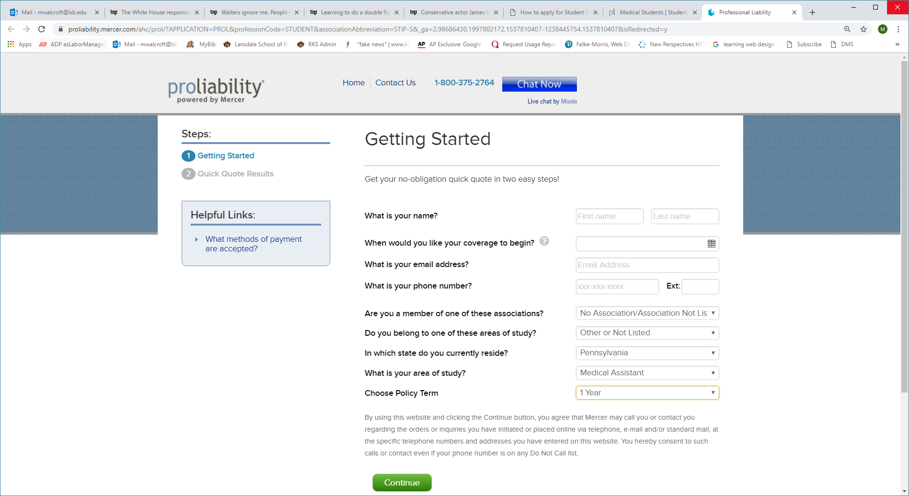
Step 5: Complete information and click Continue
Step 6: Select $43.00/PER Year. Click Apply Online & Pay Now or Print Application & Mail with check:
Step 6: Print 3 copies of your proof of purchase (receipt). 1 copy for yourself, 1 copy for your portfolio/ employment, and 1 for your MED 205, MED 121, or MED 220 instructor.
Step 7: Give copy of purchase to your MED 205, MED 121, or MED 220 instructor. You may also apply by phone at call 1-800-503-9230 to speak to a professional liability representative. As of 9/2018, the cost of this insurance was $ 43.00 per year for the required coverage of $2-$4,000,000.

