Office 365
Directions for installing Office 365 Education for Students
Once installed on your home computer, access Office 365 by signing into your LSB email account.
This plan allows currently enrolled students to install Word 2013, Excel 2013, PowerPoint 2013, Access 2013 (Access 2013 unavailable for Apple products), Publisher 2013, Outlook 2013, and OneNote on up to 5 PCs or Macs and Office apps on other mobile devices including Windows tablets and iPads®. The plan also includes 1TB of OneDrive storage, managed by the school, and students can edit and collaborate using Office Online, Yammer, and SharePoint sites.

- Go to Office 365 for Students: www.office.com/getOffice365.
- Click on n button
Find out if you’re eligible
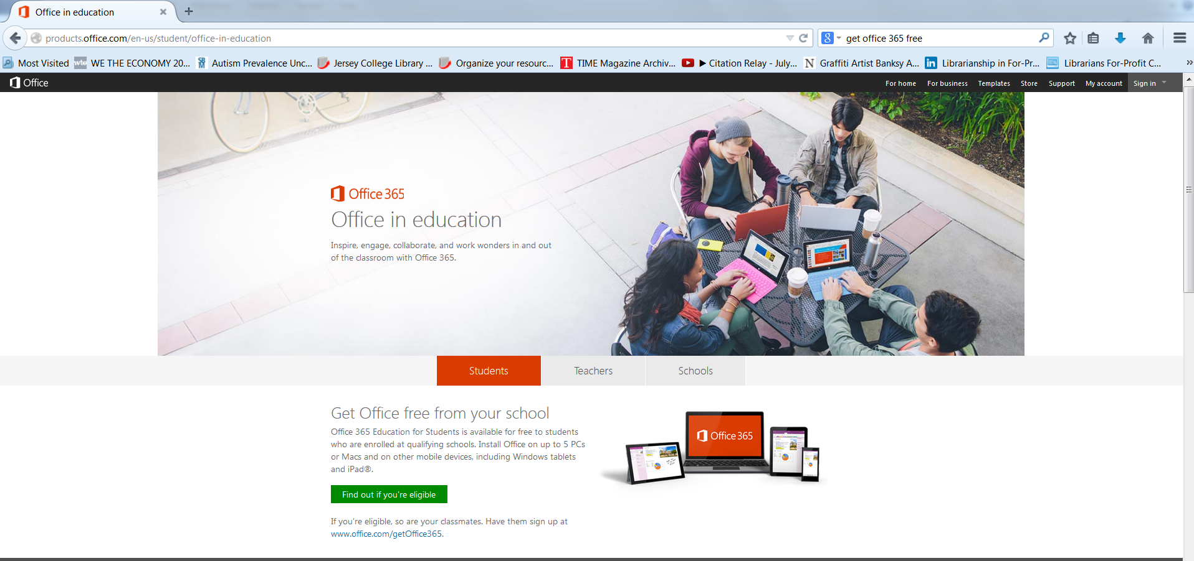
- Enter your LSB email address (yourname@lsbmail.com) and click Sign Up
Example: johndoe@lsbmail.com
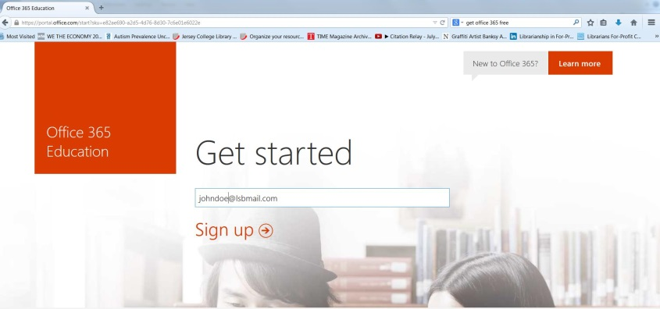
- Click Continue:
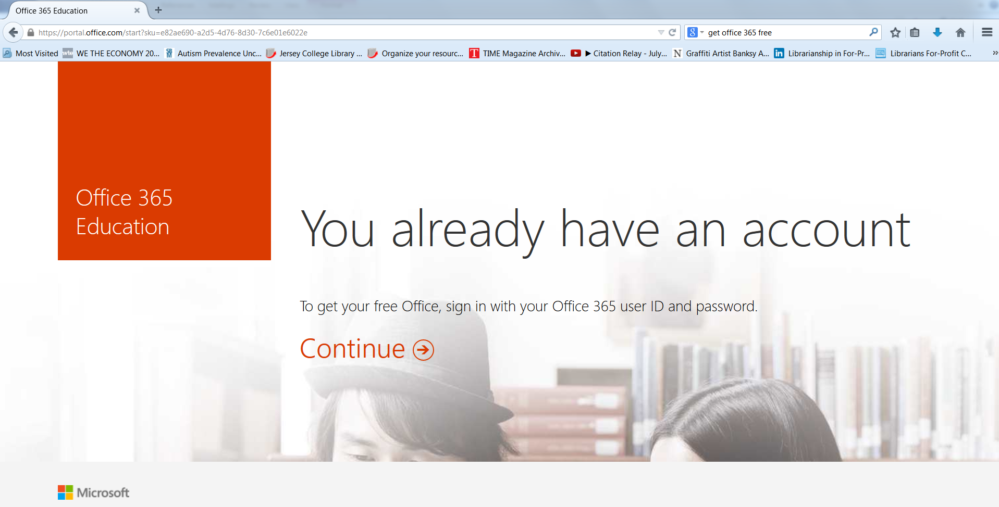
- Sign into your email account with your user name and password and click Sign in:
User name: yourname@lsbmail.com (johndoe@lsbmail.com) ;
Password: lsb and the last 4 digits of your ss# and ! (lsb1234!) if registered starting in the November 2014 term and going forward. Students registered prior to September 2014 term do not include the ! in their password (lsb1234)
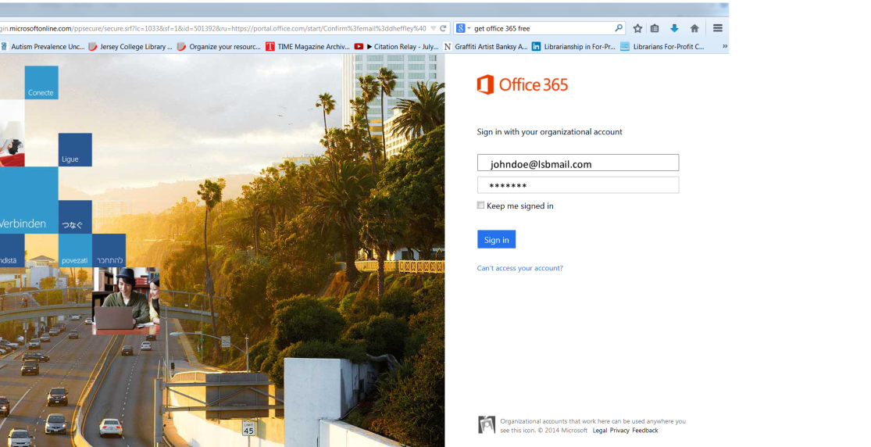

- Click Start
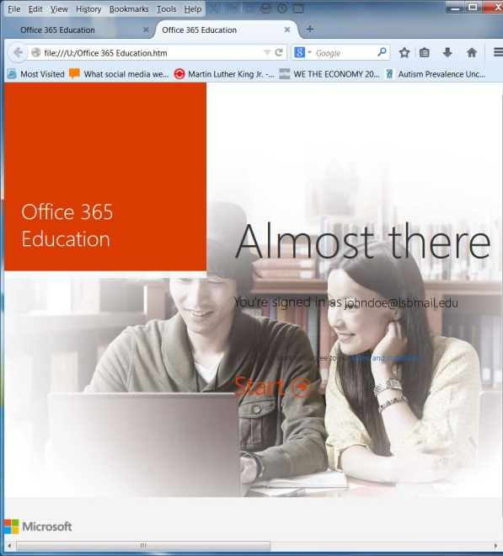

- Allow it to process
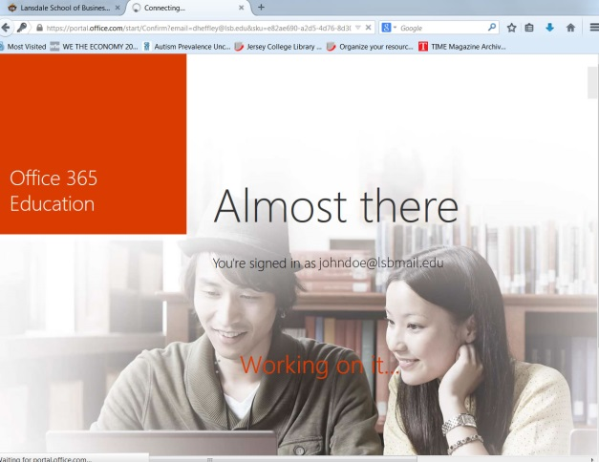

- Re-enter your user name and password and click Sign in
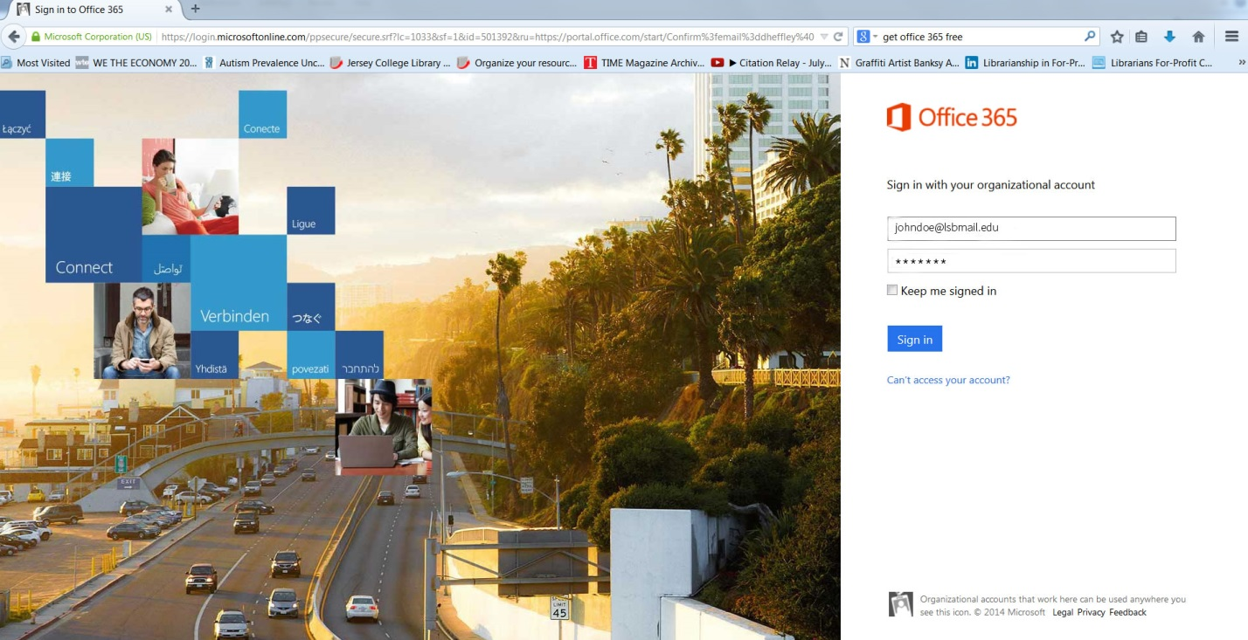

- Click Install now to install it on your home computer.

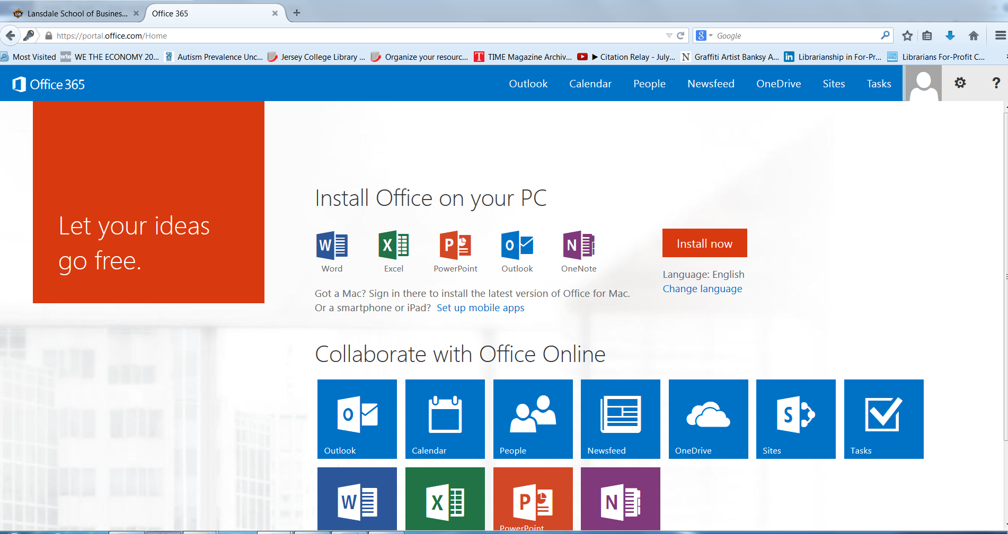

- Make sure to save your work on your Office 365 account, your home computer, your USB drive, and your P (personal) drive at LSB.

- Please note that Office 365 offers the 2013 Office suite. At present, LSB is using Office 2010 for your computer applications classes. Use Office 365 for typing and saving written work in non-computer application courses. Do not use it for homework in computer application courses that use Office 2010.

